**CIND 820:**

**Global Energy Sustainability**

By Aidan Kowolik

Student No. 500700734

Course Supervisor: Ceni Babaoglu

Due Oct, 20, 2023

Course Code CIND 820 D1H

**Abstract and Introduction:**

**Themes:**

The primary theme of the project will be using predictive analytics to predict future emissions and to compare countries against each other. Through this analysis, we hope to see what are the factors causing emissions and how these countries can lower them. By knowing these factors, recommendation systems could be put into place to advise countries on how they could lower their emissions.

**Dataset:**

The database that I’ll be using is from Kaggle and the title of it is; Global Data on Sustainable Energy (2000-2020).[1] This database was obtained from the website with the Attribution 4.0 International (CC BY 4.0) license. The historic data is obtained from countries for the last twenty years with 176 unique values with twenty-one attributes for each row of data.

**Methods:**

**Techniques:**

The primary programming language that will be used is Python and the techniques that will be used are Linear regression, K-means and Decision Tree analysis.

Linear regression will be used to predict future emissions produced based upon the factors measured with the module Sklearn with the function linear_model.LinearRegression.

K-means is used to cluster countries together to see what contributing factors toward their emissions are and the areas that need improvement or require help to lower their emissions.The module used for K-means will also be from Sklearn with the k-means function.

Decision tree will be able to classify the most important attributes from the dataset that will be a predictor for emissions. The module that will achieve this will be the decision tree classification from Sklearn as well.

**Research Questions:**

The major research questions that I will answer in this project is to predict the various countries' emission levels from the historical data and compare it against their goals. The project will identify which countries need help or are on track and to see what are the contributing factors for both scenarios.

By finding out what factors affect their emissions we can find what each country needs in terms of policy evaluation and planning to make progress towards their emissions goals.

During this project we will be able to identify countries that are in need of energy infrastructure using clustering to understand how sustainable energy could play a role in their development.

**Literature Research:**

**Global Commitment towards sustainable energy:**

The article outlines the different ways that countries are lowering their dependence on fossil fuels and increasing the amount of renewable energy sources. The reduction will be done through targets published by these countries called intended nationally determined contributions (INDCs). The primary insight from the article was that the “eight of the world’s top GHG emitters: China, Brazil, USA, EU, Indonesia, India, Mexico and Japan. These countries and regions are jointly responsible for 62% of the universal emissions and more than 65% of the earth’s basic energy requirement. (Umar & Egbu, 2019, #) From the article it gives the main countries that could have the most impact from the data analysis of this report.

**How R&D expenditure intermediate as a new determinants for low carbon energy transition in Belt and Road Initiative economies:**

The reference focuses on the link between green economic growth and sustainable development. They do achieve it by looking at how environmental regulations affect green economic growth.

The finance of “green funding is critical in fostering green innovation at the provincial level. When tangential impacts are considered, green finance factors are also significantly positive (1% level), confirming hypothesis 3. Green innovation in regional areas benefits from increased demand for environmentally friendly products and services in other locations.” (Luo & Zhang, 2022, #) Understanding the need for funds towards green initiatives will be an important factor to analyze from the dataset.

**Global Greenhouse Gas Emissions Data:**

This resource breaks down the global emissions by multiple different factors such as emissions by gas, country, economic sector and global trends. The “emissions have increased by about 90%, with emissions from fossil fuel combustion and industrial processes contributing about 78% of the total greenhouse gas emissions increase from 1970 to 2011.” (United States Environmental Protection Agency, 2023) With emissions on an unsustainable upward trend means this area is an important area to analyze and work towards lowering emissions.

**Reducing global GHG emissions by replicating successful sector examples: the ‘good practice policies’ scenario:**

The article portrays the potential impact on global greenhouse gas emissions in 2030 if all countries implemented sectoral climate policies similar to successful examples that have already been implemented in other places. It posits that “approach comes closer to what can realistically be expected from implementation of the NDCs [National Determined Contributions] or 2°C pathways than more theoretical, ‘not-real-world-proven’ assessments, we identify at least two main shortcomings.” (Roelfsema et al., 2018, #) The analysis and recommendations of this project will hope to do similar ideas of implementation of successful strategies.

**A Global Assessment: Can Renewable Energy Replace Fossil Fuels by 2050?:**

This study focused on evaluating the effectiveness of eight different solutions to completely transition from fossil fuels to renewable energy by 2050. With “[potentially], energy efficiency improvements could reduce per capita electricity use in developed countries by 50% or more over the next 30 years. (Holecheck et al., 2022, #) The reduction of energy needs means that renewable energy sources could become viable for these developing countries.

**The Role of Environmental Regulations, Renewable Energy, and Energy Efficiency in Finding the Path to Green Economic Growth:**

The paper examines the influence that environmental regulations, renewable energy and energy efficiency has on green economic growth. From this they conclude that “[expenditures] on increasing renewable energy stimulate green economic growth. In this case, the government and local authorities should stimulate consumption from green energy and implement relevant policies on promoting green technologies in all sectors.”(Dzwigol et al., 2023, #) The stimulation may work for countries that are more developed but we can see if there will be other factors in the dataset that can contribute to lowering emissions.

**Data Dictionary:**

| Attribute Name: | Data Type: | Description: |
| --- | --- | --- |
| Entity | Object | Names of the country or region for reported data |
| Year | Integer | Year for which the data is reported, ranging from 2000 to 2020 |
| Access to electricity (% of population) | Float | Percentage of population with access to electricity |
| Access to clean fuels for cooking | Float | Percentage of population with primary reliance on clean fuels |
| Renewable-electricity-generating- capacity-per-capita | Float | Installed renewable energy capacity per person |
| Financial flow to developing countries (US $) | Float | Aid and assistance from developed countries for clean energy projects |
| Renewable energy share in the total final energy consumption(%) | Float | Percentage of renewable energy in final energy consumption |
| Electricity from fossil fuels (TWh) | Float | Electricity generated from fossil fuels (coal,gas, oil) in terawatt-hours |
| Electricity from nuclear (TWh) | Float | Electricity generated from nuclear power in terawatt-hours |
| Low-carbon electricity (% electricity) | Float | Electricity generated from renewable sources (hydro, solar,wind,ect.) in terawatt-hours |
| Primary energy consumption per capita (kWh/person) | Float | Percentage of electricity from low-carbon sources (nuclear and renewables) |
| Energy intensity level of primary energy(MJ/$2017 PPP GDP) | Float | Energy use per unit of GDP at purchasing power parity |
| Value_co2_emissions_kt_by_country | Float | Carbon dioxide emissions per person in metric tons |
| Renewables(% equivalent primary energy) | Float | Equivalent primary energy that is derived from renewable sources |
| gdp_growth | Float | Annual GDP growth rate based on constant local currency |
| gdp_per_capita | Float | Gross domestic product per person |
| Density (P/Km2) | Object | Population density in persons per square kilometer |
| Land Area(Km2) | Float | Total land area in square kilometers |
| Latitude | Float | Latitude of the country’s centroid in decimal degrees |
| Longitude | Float | Longitude of the country’s centroid in decimal degrees |

**Intro Database / EDA:**

**Link to the GitHub:**

<https://github.com/A-Kowolik/Global_Energy_Sustainability>

**Number of Observation:**

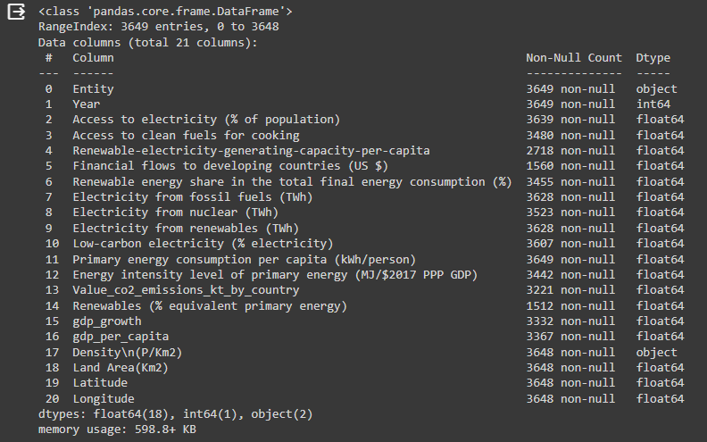

**Missing Values:**

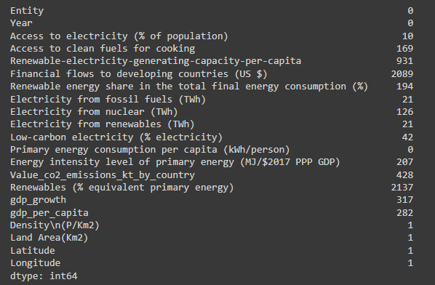

**Column Summary:**

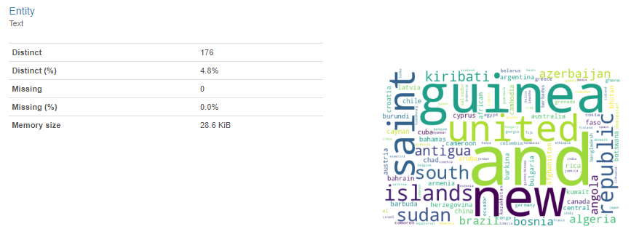

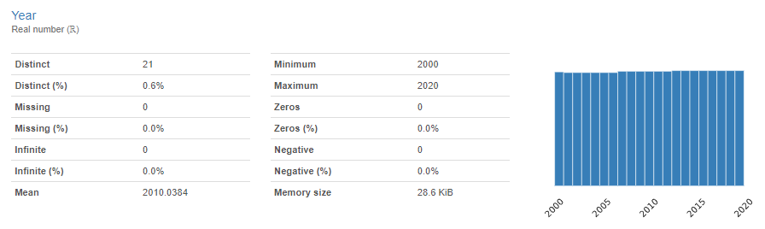

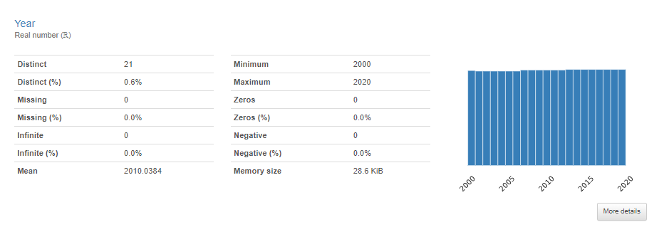

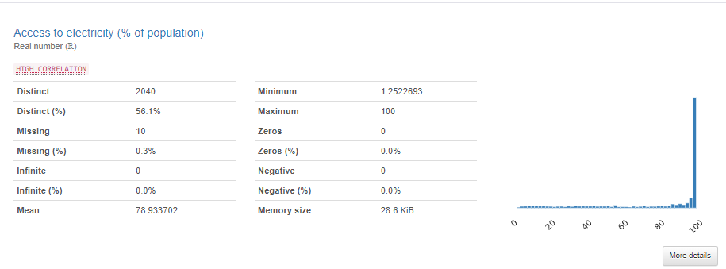

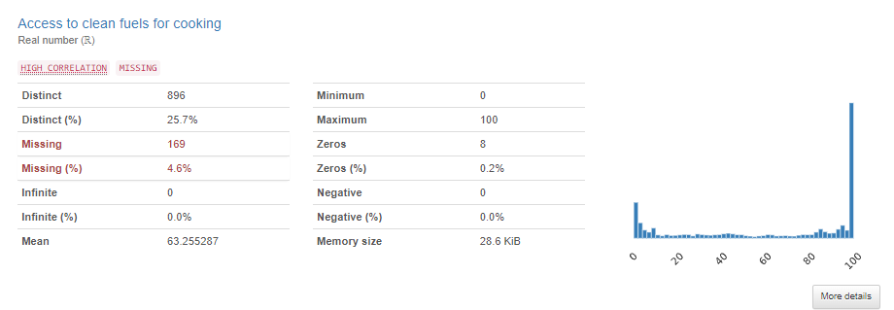

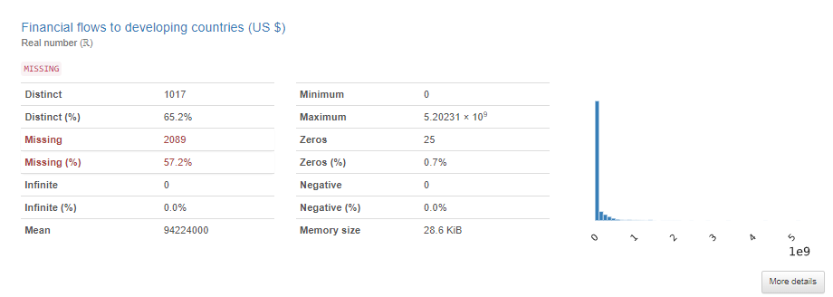

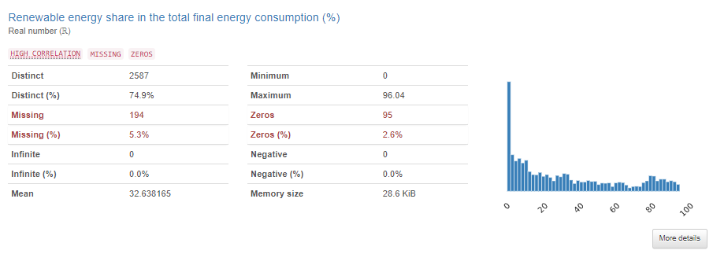

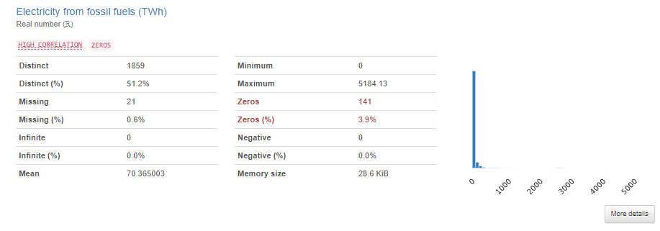

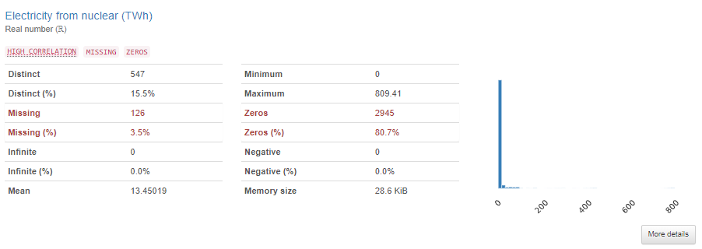

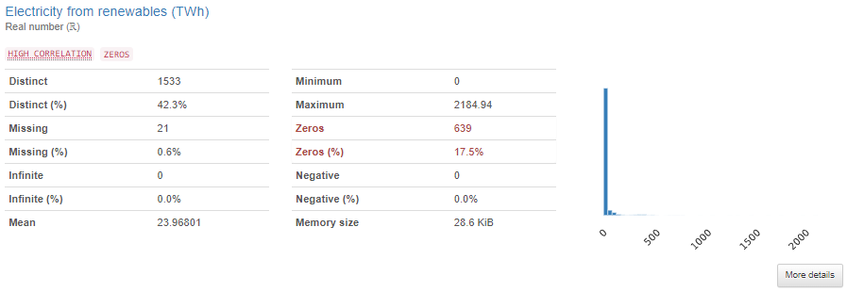

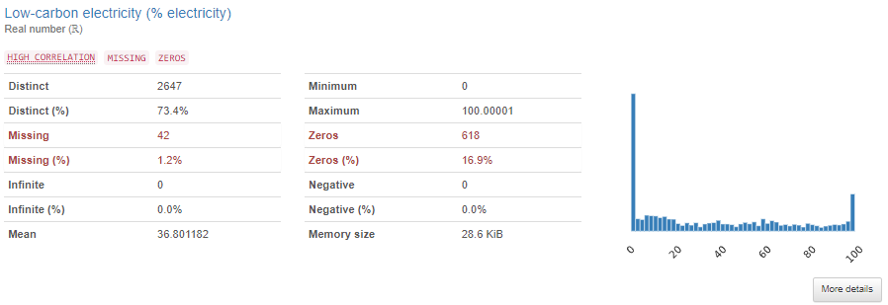

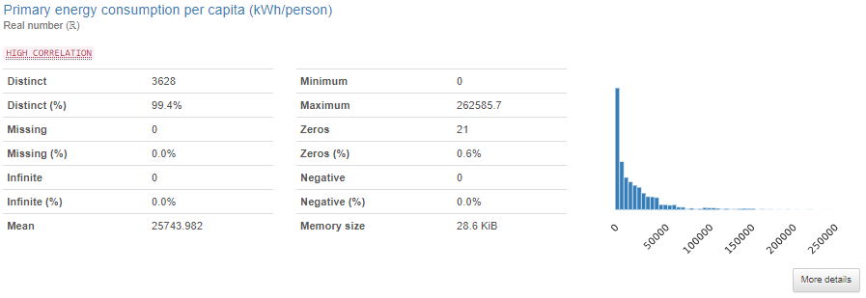

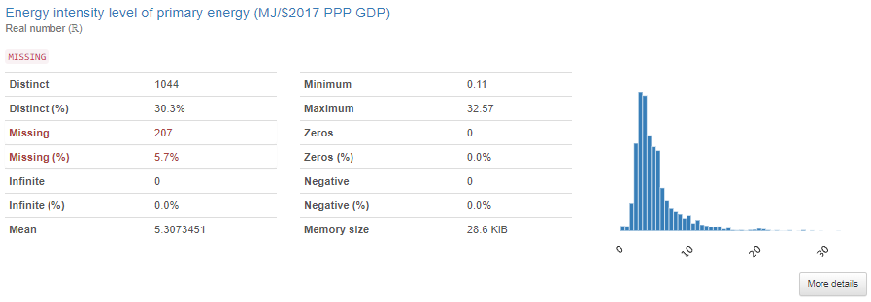

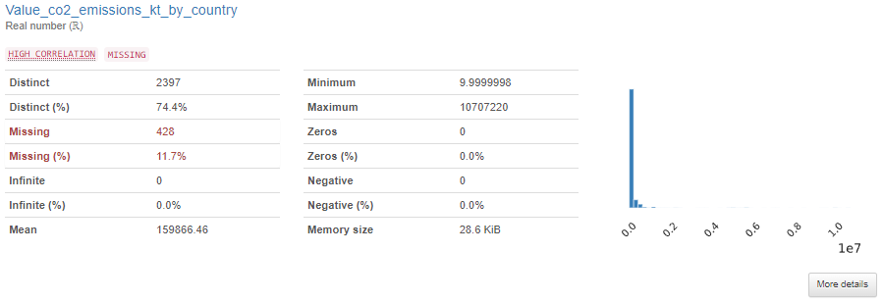

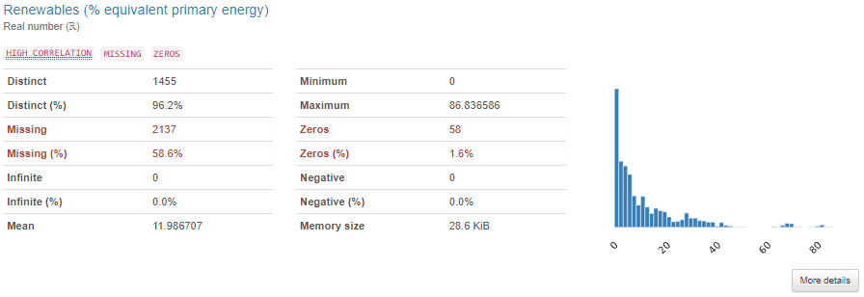

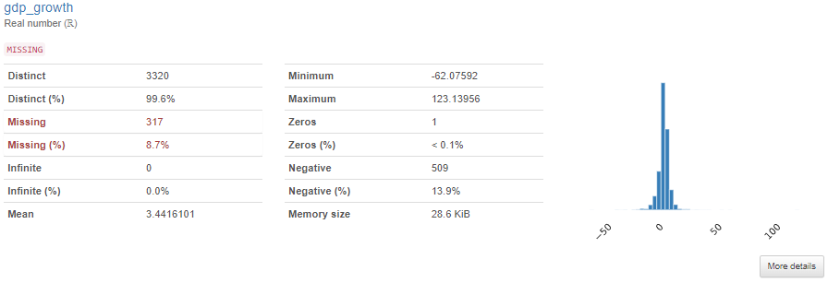

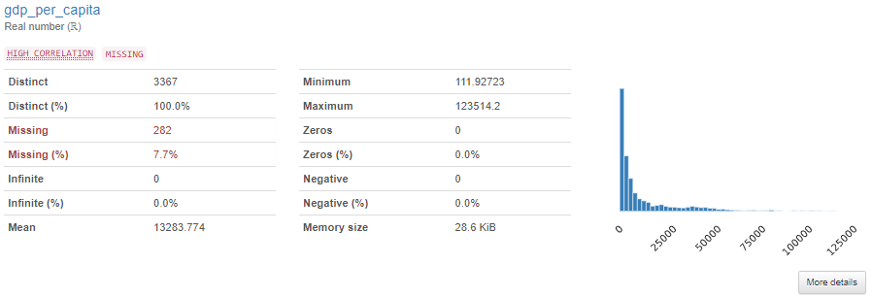

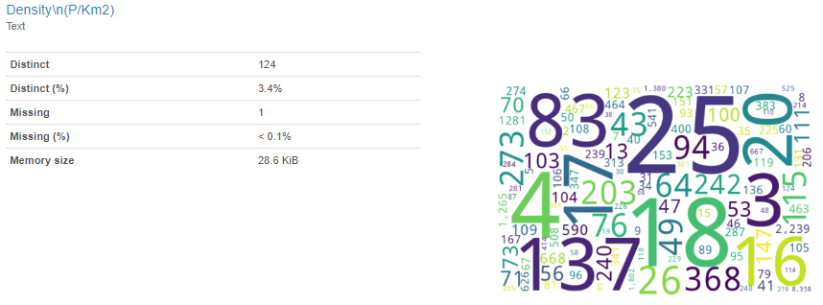

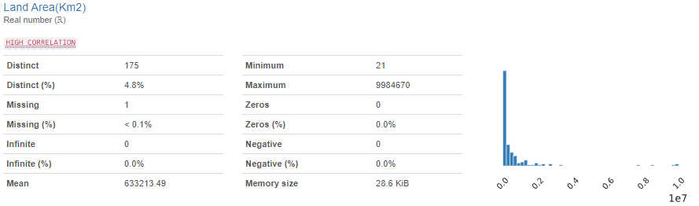

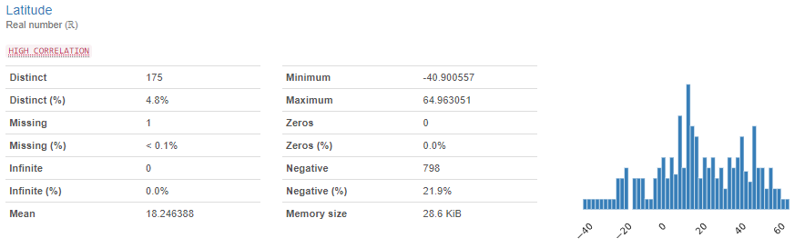

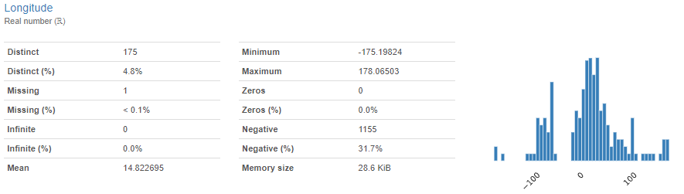

**Visualization of Null Values:**

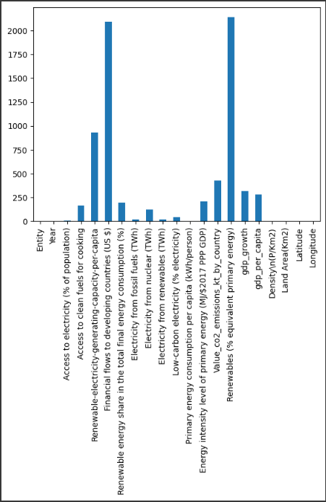

**Correlation Map:**

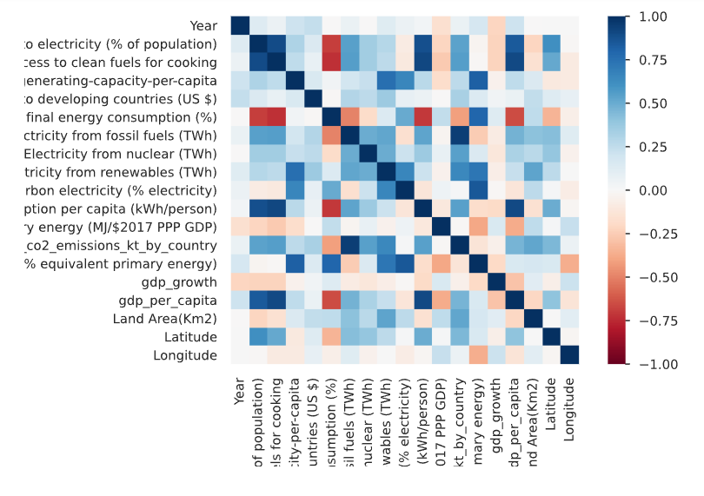

**Records By Year:**



**Country Breakdown:**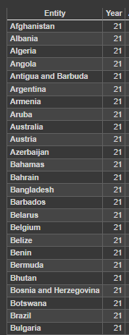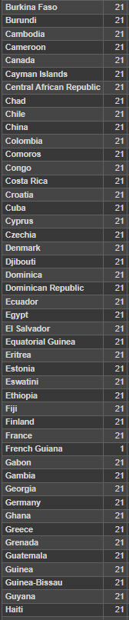



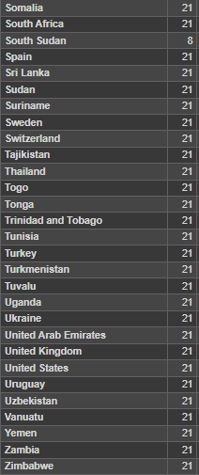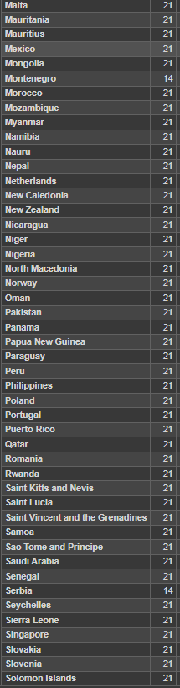

**Tentative Overall Methodology:**

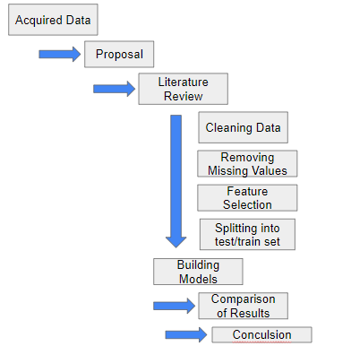

**Reference:**

Dzwigol, H., Kwilinski, A., Lyulyov, O., & Pimonenko, T. (2023). *The Role of Environmental Regulations, Renewable Energy, and Energy Efficiency in Finding the Path to Green Economic Growth*. Energies. https://www.mdpi.com/1996-1073/16/7/3090

Holecheck, J. L., Geli, H. M. E., Sawalhah, M. N., & Valdez, R. (2022). A Global Assessment: Can Renewable Energy Replace Fossil Fuels by 2050? *Sustainability*, *14*(8). https://doi.org/10.3390/su14084792

Luo, S., & Zhang, S. (2022). How R&D expenditure intermediate as a new determinants for low carbon energy transition in Belt and Road Initiative economies. *ScienceDirect*, *197*, 101-109. https://doi.org/10.1016/j.renene.2022.06.152.

Moriarty, P., & Honnery, D. (2012, January). What is the global potential for renewable energy? *ScienceDirect*, *16*(1), 244-252. https://www-sciencedirect-com.ezproxy.lib.torontomu.ca/science/article/pii/S1364032111003984

Roelfsema, M., Fekete, H., Hohne, N., Elzen, M. d., Forsell, N., Kuramochi, T., Coninck, H. d., & Vuuren, D. P. v. (2018). Reducing global GHG emissions by replicating successful sector examples: the ‘good practice policies’ scenario. *Climate Policy*, *18*(9), 1103-1113. 10.1080/14693062.2018.1481356

Umar, T., & Egbu, C. (2019). Global commitment towards sustainable energy. *Engineering Sustainability*, *172*(6), 315-323. Retrieved October, 2023, from https://www-icevirtuallibrary-com.ezproxy.lib.torontomu.ca/doi/full/10.1680/jensu.17.00059

United States Environmental Protection Agency. (2023, February). *Global Greenhouse Gas Emissions Data*. United States Environmental Protection Agency. https://www.epa.gov/ghgemissions/global-greenhouse-gas-emissions-data

1. Link to the database: https://www.kaggle.com/datasets/anshtanwar/global-data-on-sustainable-energy